

**A**

**MINI PORJECT REPORT**

**ON**

**SMART FRUIT SORTER**

FOR PARTIAL FULFILLMENT

OF THE REQUIREMENTS FOR THE

MINI PROJECT AND SEMINAR SUBJECT

OF T.E. E&TC – 2015 COURSE, SPPU, PUNE

By

**RISHABH AGARWAL T150053003**

**TITIKSHA ARORA T150053020**

**ANKITA CHINNAWAR T150053059**

**GUIDE**

**Dr. R Sreemathy**

**DEPARTMENT OF**

**ELECTRONICS AND TELECOMMUNICATION ENGINEERING**

**PUNE INSTITUTE OF COMPUTER TECHNOLOGY**

**PUNE – 43**

**ACADEMIC YEAR: 2017 - 2018**

**Department of Electronics and Telecommunication Engineering**

**Pune Institute of Computer Technology, Pune – 43**

**CERTIFICATE**

This is to certify that the Mini Project Report entitled

**SMART FRUIT SORTER**

has been successfully completed by

**RISHABH AGARWAL T150053003**

**TITIKSHA ARORA T150053020**

**ANKITA CHINNAWAR T150053059**

This is a bonafide work carried out by them under the supervision of Dr. R Sreemathy and it is approved for the partial fulfillment of the requirements for the Employability Skills and Mini Project of T.E. E&TC – 2015 Course of the Savitribai Phule Pune University, Pune.

Dr.R Sreemathy Prof. Dr. Y.Ravinder

Project Guide HOD, E&TC Dept

Place: Pune

Date :

**ACKNOWLEDGEMENTS**

We would like to express our special thanks of gratitude to our teacher and project guide Dr. Sreemathy as well as our HOD Dr. Y. Ravinder who gave us the golden opportunity to do this wonderful project on the topic Smart Fruit Sorter, which also helped us in doing a lot of research and we came to know about so many new things. We are really thankful to them. Secondly we would also like to thank our Lab assistants and our friends who helped us a lot in finalizing this project within the limited time frame.

Rishabh Agarwal

Titiksha Arora

Ankita Chinnawar

**CONTENTS**

|  |  |  |  |
| --- | --- | --- | --- |
|  | **I. Abstract** | |  |
|  | **II. List of Figures** | |  |
|  | **III. List of Tables** | |  |
|  |  | |  |
| 1 | **Introduction** | | 9 |
|  | 1.1 | Aim | 12 |
|  | 1.2 | Problem Statement | 12 |
|  | 1.3 | Brief History | 12 |
|  | 1.4 | Literature Survey | 12 |
|  | 1.5 | Scope | 14 |
|  | 1.6 | Objectives | 14 |
|  | 1.7 | Technical Survey | 15 |
|  |  |  |  |
| 2 | **Block Diagram Description** | | 16 |
|  | 2.1 | Block diagram | 17 |
|  | 2.2 | Flow of Project | 18 |
|  |  |  |  |
| 3 | **System Design** | | 19 |
| 4 | **SVM Classifier** | | 26 |
| 5 | **Data Training** | | 28 |
| 6 | **Codes** | | 30 |
| 7 | **Results** | | 37 |
| 8 | **Conclusions** | | 42 |
| 9 | **Future Scope** | | 44 |
| 10 | **Bill of Material** | | 46 |
| 11 | **References** | | 48 |
| 12 | **Datasheets** | | 50 |

**ABSTRACT**

Our project is Smart Fruit Sorter, where we have made successful efforts to build a product for farmers and people who are connected to agriculture to recognize the ripeness of fruit. It is a prototype model which can be extended on a large scale using the same principle. So, in this project we have made a sorter for lemons and for the same we have tried to build a product which captures the images of lemon through a camera , and tells the ripeness of lemon present in the image captured. In this project we are using a Webcam as an Optical Sensor to capture the images, after that the image goes to the Raspberry Pi, which processes the data and finally the output is provided using SVM classifier and moved to the bowl for that particular quality of lemon. So using this technique the user can get an idea of the quality of any fruit.

**LIST OF FIGURES**

|  |  |  |  |
| --- | --- | --- | --- |
| S.No. | Figure No. | Description | Page No. |
| 1. | 2.1 | Bock Diagram | 17 |
| 2. | 3.1 | Webcam | 21 |
| 3. | 3.2 | Raspberry Pi | 22 |
| 4. | 3.3 | Pin Diagram | 22 |
| 5. | 3.4 | NRS 995 Motor | 23 |
| 6. | 3.5 | Flowchart | 26 |
| 7. | 4.1 | SVM Illustrations | 28 |
| 8. | 7.1 | Hardware Setup | 39 |
| 9. | 7.2 | Lemon 1 | 40 |
| 10. | 7.3 | Lemon 2 | 40 |
| 11. | 7.4 | Lemon 3 | 41 |
| 12. | 7.5 | Result | 42 |

**LIST OF TABLES**

|  |  |  |  |
| --- | --- | --- | --- |
| S.No. | Table No. | Description | Page No. |
| 1. | 1.1 | Comparison between Rpi and Arduino | 15 |
| 2. | 3.1 | Specifications of Rpi | 23 |
| 3. | 7.1 | Statistics | 42 |
| 4. | 10.1 | Bill of Materials | 48 |

**CHAPTER 1**

**INTRODUCTION**

**INTRODUCTION**

Fruit commercialization is the main purpose of its sorting.

• Fruit in the same tree differ in quality such as feature, flavour because their growth was affected by many environmental factors. Especially, fruit from different orchards differ significantly in size and quality.

•Sorting may not only standardize fruit product but also promote management of the fruit tree in orchard and product quality. Fruits and vegetables are very difficult to grade and sort exactly and rapidly because of their significant difference in feature such as size, shape and color as a result of changeable conditions of nature environment and manual factors.

•Manual sorting is lack of objectivity, accuracy and has lower efficiency because there is individual difference in visual inspecting which is affected by human healthy condition, psychological condition, lightness, fatigue and so on. Levels of mechanical and automatic grading of fruit and vegetable go higher and higher with the enhancement of mechanization, automatization and application of computer technology.

**MOTIVATION**

The naked eye observation of experts is the main approach adopted in practice for detection and identification of plant diseases. But, this requires continuous monitoring of experts which might be prohibitively expensive in large farms. Further, in some developing countries, farmers may have to go long distances to contact experts, this makes consulting experts too expensive and time consuming and moreover farmers are unaware of non-native diseases. In order to improve the fruits’ quality and production efficiency, to reduce labor intensity, it is necessary to research nondestructive automatic detection technology. Fruit nondestructive detection is the process of detecting fruits’ inside and outside quality without any destructive, using some detecting technology to make evaluation according some standard rules. Nowadays, the quality of fruit shape, default, color and size and so on cannot evaluate on line by using traditional methods. With the development of image processing technology and computer software and hardware, it becomes more attractive to detect fruits’ quality by using vision detecting technology. At present, most existing fruit quality detection and grading system have the disadvantage of low efficiency, low speed of grading, high cost and complexity. So it is significant to develop high speed and low cost fruit size detecting and grading system.

* 1. **AIM OF THE PROJECT**

Smart Fruit Sorter using Image Processing and Machine Learning

* 1. **PROBLEM STATEMENT**

To design of a system for the analysis of the fruit and classification based on ripeness (color) and grading as well as sorting these fruits in different categories for the commercial purposes.

* 1. **BRIEF HISTORY**

The quality inspection of fruits is performed by human experts. This manual sorting by visual inspection is labor intensive, time consuming and suffers from the problem of inconsistency and inaccuracy in judgment by different human. With the advent of fast and high precision machine vision technologies, automation of the grading process is expected to reduce labor cost, improve the efficiency and accuracy of the sorting process.

* 1. **LITERATURE SURVEY**

There are different methods that can be used to implement this project. By doing survey, different methods that were found out are as follows:

1. Machine vision based automatic fruit grading system using fuzzy algorithm

The present paper proposes a machine vision based scheme for automatic grading of fruits according to their maturity level and quality. The fruit used in the study is mango (Mangifera Indica L.). The manual grading by visual inspection poses problems in maintaining consistency and accuracy; this is also time consuming and labor intensive process. In this project a new prototype computer vision based automatic fruit grading systems is proposed. The automated system collects video image from the CCD camera placed on the top of a conveyor belt carrying mangoes, then it processes the images in order to collect several relevant features which are sensitive to the maturity level and quality. Finally fuzzy rule based algorithm is used to sort the fruits into four grades.

1. An automated machine vision based system for fruit sorting and grading

The paper presents a computer vision based system for automatic grading and sorting of agricultural products like Mango (Mangifera indica L.) based on maturity level. The application of machine vision based system, aimed to replace manual based technique for grading and sorting of fruit. The manual inspection poses problems in maintaining consistency in grading and uniformity in sorting. To speed up the process as well as maintain the consistency, uniformity and accuracy, a prototype computer vision based automatic mango grading and sorting system was developed. The automated system collect video image from the CCD camera placed on the top of a conveyer belt carrying mangoes, then it process the images in order to collects several relevant features which are sensitive to the maturity level of the mango. Finally the parameters of the individual classes are estimated using Gaussian Mixture Model for automatic grading and sorting.

1. Thresholding - based segmentation and apple grading by machine vision

In this paper, a computer vision based system is introduced to automatically grade apple fruits. Segmentation of defected skin is done by three global thresholding techniques (Otsu, isodata and entropy). Stem-end/calyx regions falsely classified as defect are removed. Segmentations were visually best with isodata technique applied on 750nm filter image. Statistical features are extracted from the segmented areas and then fruit is graded by a supervised classifier. Linear discriminant, nearest neighbor, fuzzy nearest neighbor, adaboost and support vector machines classifiers are tested for fruit grading, where the latter outperformed others with 89 % recognition.

1. Virtual Grader for Apple Quality Assessment using Fruit Size and Illumination Features

The present paper reports on the development of an intelligent virtual grader for assessing apple quality using machine vision. The heart of the proposed virtual grader was executed in the form of K-Nearest Neighbor (K-NN) classifier designed on the architecture of Euclidean distance metric. KNN classifier is executed for this particular application due to its robustness to the noisy environment. The present study revealed that fruit surface illumination is one of the major deterministic parameters affecting accuracy substantially while assessing apple quality based on fruit size. The performance of the proposed virtual grader was examined experimentally under different conditions of fruit surface illumination. An industrial grade camera connected to an image grabber was used to implement the proposed industrial-grade virtual grader using machine vision. Results of this study are quite promising with an achievement of 99% efficiency at 100% repeatability when fruit surface is exposed to an optimal value of 310 lux. However, such an attempt has not been made earlier.

* 1. **SCOPE**
* Detect the quality of any fruit
* To segregate the fruits which look similar
* Include Different algorithms of Machine Learning to automatically train the product
* Using Algorithms to to sort the fruit using feature vectors other than colour, example: Size
  1. **OBJECTIVES**
* Develop a gadget that will aid farmers to segregate the fruits which are raw, ripe or rotten.
* Give maximum efficient results with minimum errors.
* To develop the gadget at affordable costs.
  1. **TECHNICAL SURVEY**

|  |  |  |  |
| --- | --- | --- | --- |
| Sr.No. | Feature | Raspberry Pi | Arduino |
| 1. | Programming Language | No limit | Arduino |
| 2. | Processor Speed | 1.2 GHz | 16MHz |
| 3. | Internet connection very easy | Not easy | Doable |
| 4. | Hardware design | Closed source | Open source |
| 5. | Real time | Hardware real time | In real time |
| 6. | Analog to Digital | No | Yes |

Table 1.1 Comparison between Raspberry Pi and Arduino

**CHAPTER 2**

**BLOCK DIAGRAM DESCRIPTION**

**2.1 BLOCK DIAGRAM**

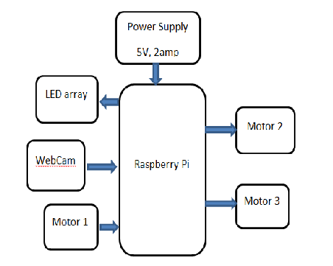

Figure 2.1 Block Diagram

**2.2 FLOW OF PROJECT**

* Taking Image from Optical Sensor

The fruit is placed on a small disk whose angle is controlled with the help of a motor. Image is captured using a webcam which acts as an optical sensor. It gives a 8 MP resolution. 3 images are captured from 3 different angles.

* Processing the image using different Image Processing Algorithms

After the image is captured through the Webcam it is sent to the SOC, i.e. the Raspberry Pi. RasPi basically performs the IP algorithms on the image using various functions of OpenCV library. The steps are as follows:

1. Read the captured Image.
2. Convert it into HSV and split the image in their vales of H,S,V
3. Give the threshold value to the threshold function only for S-plane.
4. Invert the image after applying threshold
5. Use Kernel filter to remove the noise
6. Using morphological function of closing
7. Bitwise anding of the actual image and Bitwise not the closed image to remove the background.
8. Split the RGB components and HSV components of the image and find the mean and standard deviation as a feature vector.

* Classifying the image into the right class

The feature vector received from the image processing is sent to the Machine Learning (ML) algorithm for classifying. The classification is done into 3 classes as- Ripe( Yellow), Raw (Green) and Rotten (Brown). The ML algorithm used for classification is Support Vector Machine (SVM). We have used functions from scikit-learn library. An already trained model is used and then the class prediction of the new feature vector is performed.

* Putting the lemons in the respective bins

According to the classified lemon, rotate the bigger disk towards the required bowl. Tilt the 3rd motor at an angle for the fruit to drop in that bowl. Final output is putting the lemon in the respective bin according to the classification.

**CHAPTER 3**

**SYSTEM DESIGN**

**HARDWARE REQUIREMENTS**

* Sony CMU-BR 300

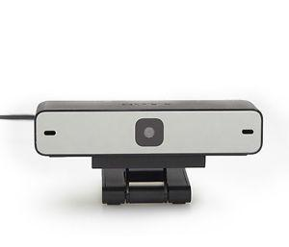

Figure 3.1 Webcam

Resolution: 1920x1080

USB 2.O A type

Fixed Focus

Weight: 75 grams

* Raspberry Pi

Raspberry Pi board is a fully functional computer or full-fledged credit card sized. It has all the trappings of a computer, with a dedicated memory, processor, and a graphics card for output through HDMI. It even runs a specially designed version of the Linux operating system and it is easy to install in most Linux software, and used the Raspberry Pi as a functioning video game emulator or media streamer with a bit of effort.

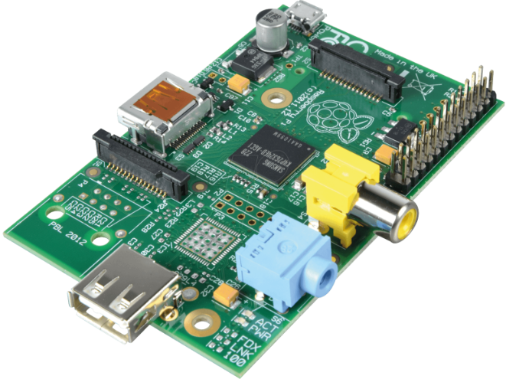

Figure 3.2 Raspberry Pi

Though the Raspberry Pi doesn’t offer internal storage, we can use SD cards as the flash memory in the total system, allowing you to quickly swap out different versions of the operating system or software updates to debug. Because of this device is independent network connectivity, you can also set it up to access via SSH, or transfer files to it using FTP. It is having 1 GB RAM, 1.2 GHz microprocessor and hardware support for SPI, I2C and Serial.

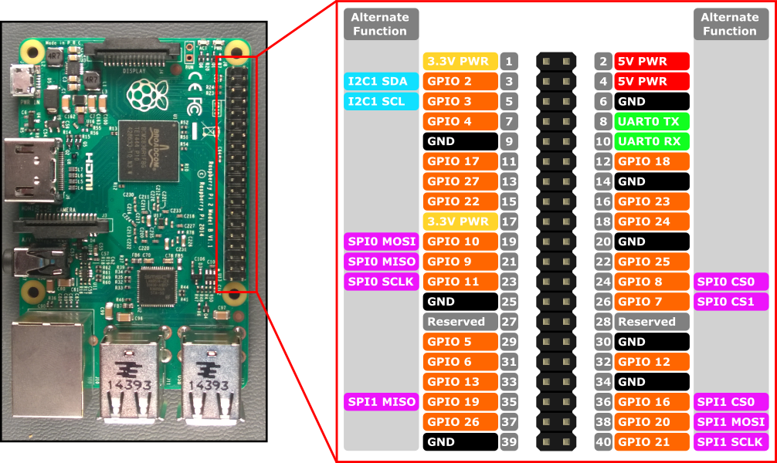

Figure 3.3 Pin Diagram of Raspberry Pi

Technical details:

|  |  |
| --- | --- |
| Brand | Raspberry Pi |
| Series | Model B |
| Item Height | 34 Millimeters |
| Item Width | 7.6 Centimeters |
| CPU Clock | 1.2GHz |
| Item Weight | 68 g |
| Product Dimensions | 12.2 x 7.6 x 3.4 cm |
| Item model number | RASPBERRYPI3-MODB-1GB |
| Processor Count | 4 |
| RAM Size | 1 GB |
| Wireless Type | 802.11 B/G |
| Number of USB 2.0 Ports | 4 |
| Operating System | Ubuntu Mate, Snappy Ubuntu Core, PINET, Windows 10 IOT, Raspbian, Pidora, OSMC, OpenElec, RISC OS, Arch Linux |
| Included Components | Motherboard |

Table 3.1 Specifications of Raspberry Pi

Motors

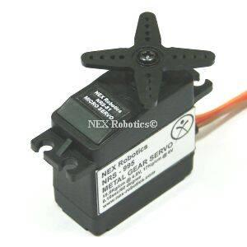

Figure 3.4 Motor: NRS995

|  |  |
| --- | --- |
| Brand: NEX ROBOTICS  Dimension: 40.7mm x 20.5mm x39.5mm  Torque: 15.5kg/cm at 4.8V, 17kg/cm at 6V  Dual bearing with metal gear  Motor weight: 60gms  Operating speed: 0.15sec/60 degree  Operating voltage: 4.8V to 6V  Temperature range: 0-55C  0.6 ms for 0 degree Rotation |  |
|  |  |
|  |  |
|  |  |
|  |  |
|  |  |
| **SOFTWARE**   * Raspbian Jessie (Operating System)   Raspbian is a free operating system based on Debian optimized for the Raspberry Pi hardware. An operating system is the set of basic programs and utilities that makes Raspberry Pi run. However, Raspbian provides more than a pure OS: it comes with over 35,000 packages, pre-compiled software bundled in a nice format for easy installation on Raspberry Pi.   * OpenCV   OpenCV (Open Source Computer Vision) is a [library of programming functions](https://en.wikipedia.org/wiki/Library_(computing)) mainly aimed at real-time [computer vision](https://en.wikipedia.org/wiki/Computer_vision). Originally developed by [Intel](https://en.wikipedia.org/wiki/Intel_Corporation)'s research center in [Nizhny Novgorod](https://en.wikipedia.org/wiki/Nizhny_Novgorod) (Russia), it was later supported by [Willow Garage](https://en.wikipedia.org/wiki/Willow_Garage) and is now maintained by Itseez. The library is [cross-platform](https://en.wikipedia.org/wiki/Cross-platform) and free for use under the [open-source](https://en.wikipedia.org/wiki/Open-source) [BSD license](https://en.wikipedia.org/wiki/BSD_license).   * Scikit-learn   Scikit-learn is a [free software](https://en.wikipedia.org/wiki/Free_software) [machine learning](https://en.wikipedia.org/wiki/Machine_learning) [library](https://en.wikipedia.org/wiki/Library_(computing)) for the [Python](https://en.wikipedia.org/wiki/Python_(programming_language)) programming language. It features various [classification](https://en.wikipedia.org/wiki/Statistical_classification), [regression](https://en.wikipedia.org/wiki/Regression_analysis) and [clustering](https://en.wikipedia.org/wiki/Cluster_analysis) algorithms including [support vector machines](https://en.wikipedia.org/wiki/Support_vector_machine), [random forests](https://en.wikipedia.org/wiki/Random_forests), [gradient boosting](https://en.wikipedia.org/wiki/Gradient_boosting), [*k*-means](https://en.wikipedia.org/wiki/K-means_clustering) and [DBSCAN](https://en.wikipedia.org/wiki/DBSCAN), and is designed to interoperate with the Python numerical and scientific libraries [NumPy](https://en.wikipedia.org/wiki/NumPy) and [SciPy](https://en.wikipedia.org/wiki/SciPy).  **Python**  Python is a widely used [high-level programming language](https://en.wikipedia.org/wiki/High-level_programming_language) for [general-purpose programming](https://en.wikipedia.org/wiki/General-purpose_programming_language), created by [Guido van Rossum](https://en.wikipedia.org/wiki/Guido_van_Rossum) and first released in 1991. An [interpreted language](https://en.wikipedia.org/wiki/Interpreted_language), Python has a design philosophy which emphasizes code [readability](https://en.wikipedia.org/wiki/Readability) (notably using [whitespace](https://en.wikipedia.org/wiki/Whitespace_character) indentation to delimit [code blocks](https://en.wikipedia.org/wiki/Code_block) rather than curly braces or keywords), and a syntax which allows programmers to express concepts in fewer [lines of code](https://en.wikipedia.org/wiki/Source_lines_of_code) than possible in languages such as [C++](https://en.wikipedia.org/wiki/C%2B%2B) or [Java](https://en.wikipedia.org/wiki/Java_(programming_language)). The language provides constructs intended to enable writing clear programs on both a small and large scale.  **FLOWCHART**    Figure 3.5 Flowchart |  |

**CHAPTER 4**

**SUPPORT VECTOR MACHINE**

Machine Learning algorithms are an armory packed with axes, sword, blades, bow, dagger etc. You have various tools, but you ought to learn to use them at the right time. As an analogy, think of ‘Regression’ as a sword capable of slicing and dicing data efficiently, but incapable of dealing with highly complex data. On the contrary, ‘Support Vector Machines’ is like a sharp knife – it works on smaller datasets, but on them, it can be much more stronger and powerful in building models.

Support Vector Machine (SVM) is a supervised machine learning algorithm which can be used for both classification or regression challenges. However, it is mostly used in classification problems. In this algorithm, we plot each data item as a point in n-dimensional space (where n is number of features you have) with the value of each feature being the value of a particular coordinate. Then, we perform classification by finding the hyperplane that differentiate the two classes very well.

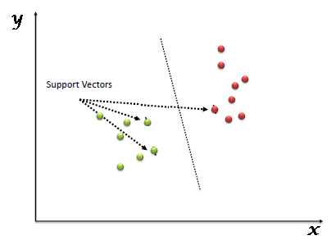

Figure 4.1 SVM illustrations

Support Vectors are simply the coordinates of individual observation. Support Vector Machine is a frontier which best segregates the two classes. More formally, a support vector machine constructs a [hyperplane](https://en.wikipedia.org/wiki/Hyperplane) or set of hyperplanes in a [high-](https://en.wikipedia.org/wiki/High-dimensional_space) or infinite-dimensional space, which can be used for [classification](https://en.wikipedia.org/wiki/Statistical_classification), [regression](https://en.wikipedia.org/wiki/Regression_analysis), or other tasks like outliers detection. Intuitively, a good separation is achieved by the hyperplane that has the largest distance to the nearest training-data point of any class (so-called functional margin), since in general the larger the margin the lower the [generalization error](https://en.wikipedia.org/wiki/Generalization_error) of the classifier.

We have used 12 features for each training example. These come from the different color schemes (HSV, RGB) of the image processing algorithm. There are 3 classes into which each test example must be classified. The SVM function from the sklearn library is used to make the classification function. Once created, it is used to predict the class of the test example.

**CHAPTER 5**

**DATA TRAINING**

A feature vector consists of the values of certain characteristics of a fruit. We ran our software on a number of lemons of differing colors among yellow, green and brown. The three classes created are Ripe, Raw and Rotten.

Thus, a dataset with the features of about 100 lemons was made into a “.csv” file. This formed the training dataset for our SVM algorithm. The “fit()” function was used to make the classification function.

Now, any input feature vector was given to the “predict()” function and the SVM classified it into Ripe, Raw or Rotten.

**CHAPTER 6**

**CODE**

**CODE FOR DETECTION OF QUALITY OF FRUITS ALONG WITH INTERFACING OF 3 MOTORS, LED ARRAY AND WEBCAM**

import numpy as np

import pandas as pd

import cv2

import RPi.GPIO as GPIO

import time

import pygame

#from pygame.locals import *

import pygame.camera

from sklearn.svm import SVC #"Support Vector Classifier"

pygame.init()

pygame.camera.init()

LED1 =36;LED2=38;LED3=40;

i=0;j=0;

GPIO.setmode(GPIO.BOARD)

GPIO.setup(LED1, GPIO.OUT)

GPIO.setup(LED2, GPIO.OUT)

GPIO.setup(LED3, GPIO.OUT)

GPIO.setup(11,GPIO.OUT) #big disk

GPIO.setup(13,GPIO.OUT) #tilt

GPIO.setup(7,GPIO.OUT) #small disk

pwm2=GPIO.PWM(11,100)

pwm3=GPIO.PWM(13,100)

pwm1=GPIO.PWM(7,100)

GPIO.output(LED1,True)

time.sleep(2)

GPIO.output(LED1,False)

GPIO.output(LED2,True)

time.sleep(2)

GPIO.output(LED2,False)

GPIO.output(LED3,True)

time.sleep(2)

GPIO.output(LED3,False)

pwm1.start(5)

pwm2.start(5)

pwm3.start(5)

pwm1.ChangeDutyCycle(0)

pwm2.ChangeDutyCycle(0)

pwm3.ChangeDutyCycle(0)

'''---------ML CODE-------'''

x = pd.read_csv("output.csv")

a= np.array(x)

y = a[:,12]

x = a[:,:12]

#x.shape

#print (x)

#print (y)

clf = SVC(kernel='linear')

clf.fit(x, y)

'''======trained the data====='''

'''-----------LED CODE-----------'''

#GPIO.output(LED1,True)

GPIO.output(LED2,True)

#GPIO.output(LED3,True)

pwm1.ChangeDutyCycle(0)

pwm2.ChangeDutyCycle(0)

pwm3.ChangeDutyCycle(0)

time.sleep(2)

GPIO.output(LED2,False)

GPIO.output(LED1,True)

GPIO.output(LED3,True)

i=0;j=0;

meanh=0.0;means=0.0;meanv=0.0;meanr=0.0;meang=0.0;meanb=0.0;

stdevh=0.0;stdevs=0.0;stdevv=0.0;stdevr=0.0;stdevg=0.0;stdevb=0.0;

while (j<3):

pwm1.ChangeDutyCycle(0)

angle = j*120

duty0=(float)(angle)/10+2.5

pwm1.ChangeDutyCycle(duty0)

time.sleep(5) #wait 5 sec before capture

GPIO.output(LED2,False)

time.sleep(1)

GPIO.output(LED2,True)

GPIO.output(LED1,True)

GPIO.output(LED3,True)

'''----------CAMERA CAPTURE------------'''

cam = pygame.camera.Camera("/dev/video0",(400,300))

cam.start()

image= cam.get_image()

pygame.image.save(image,r'/home/pi/Desktop/MiniProject/testimage1.jpg')

cam.stop()

time.sleep(2)

'''#IMP--> Change path name and file names'''

GPIO.output(LED1,False)

GPIO.output(LED2,False)

GPIO.output(LED3,False)

img = cv2.imread("101.jpg")

crop_img = img[80:300, 70:220]

#cv2.imshow("testimage.jpg", crop_img)

cv2.imwrite('testimage.jpg',crop_img)

'''------------TEST CLONING----------'''

imgx= cv2.imread('testimage.jpg')

hsv_img= cv2.cvtColor(imgx, cv2.COLOR_BGR2HSV)

h,s,v = cv2.split(hsv_img)

cv2.imwrite('splane.png',s)

img= cv2.imread('splane.png')

ret,thresh2=cv2.threshold(img,55, 255,cv2.THRESH_BINARY_INV)

kernel = np.ones((5,5),np.uint8)

closing=cv2.morphologyEx(thresh2,cv2.MORPH_CLOSE, kernel)

mask_inv=cv2.bitwise_not(closing)

cv2.imwrite('closed_image.png',closing)

mask_inv=cv2.bitwise_and(mask_inv,imgx)

cv2.imwrite('wo_back.jpg',mask_inv)

'''----------------COLOR VECTOR---------------'''

img1= cv2.imread('wo_back.jpg')

r1, g1, b1= cv2.split(img1)

hsv_img1= cv2.cvtColor(img1, cv2.COLOR_BGR2HSV)

h1,s1,v1= cv2.split(hsv_img1)

tmeanh,_,_,_=cv2.mean(h1)

tmeans,_,_,_=cv2.mean(s1)

tmeanv,_,_,_=cv2.mean(v1)

tmeanr,_,_,_=cv2.mean(r1)

tmeang,_,_,_=cv2.mean(g1)

tmeanb,_,_,_=cv2.mean(b1)

tstdevh=np.std(h1)

tstdevs=np.std(s1)

tstdevv=np.std(v1)

tstdevr=np.std(r1)

tstdevg=np.std(g1)

tstdevb=np.std(b1)

meanh= (float)(meanh);

means= (float)(means);

meanv= (float)(meanv);

meanr= (float)(meanr);

meang= (float)(meang);

meanb= (float)(meanb);

stdevh= (float)(stdevh);

stdevs= (float)(stdevs);

stdevv= (float)(stdevv);

stdevr= (float)(stdevr);

stdevg= (float)(stdevg);

stdevb= (float)(stdevb);

tmeanh= (float)(format(tmeanh, '.4f'))

tmeans= (float)(format(tmeans, '.4f'))

tmeanv= (float)(format(tmeanv, '.4f'))

tmeanr= (float)(format(tmeanr, '.4f'))

tmeang= (float)(format(tmeang, '.4f'))

tmeanb= (float)(format(tmeanb, '.4f'))

tstdevh= (float)(format(tstdevh, '.4f'))

tstdevs= (float)(format(tstdevs, '.4f'))

tstdevv= (float)(format(tstdevv, '.4f'))

tstdevr= (float)(format(tstdevr, '.4f'))

tstdevg= (float)(format(tstdevg, '.4f'))

tstdevb= (float)(format(tstdevb, '.4f'))

meanh= meanh+tmeanh

means= means+tmeans

meanv= meanv+tmeanv

meanr= meanr+tmeanr

meang= meang+tmeang

meanb= meanb+tmeanb

stdevh= stdevh+tstdevh

stdevs= stdevs+tstdevs

stdevv= stdevv+tstdevv

stdevr= stdevr+tstdevr

stdevg= stdevg+tstdevg

stdevb= stdevb+tstdevb

j=j+1

pwm1.ChangeDutyCycle(0)

stdevh=(float)(stdevh/3)

stdevs=(float)(stdevs/3)

stdevv=(float)(stdevv/3)

stdevr=(float)(stdevr/3)

stdevg=(float)(stdevg/3)

stdevb=(float)(stdevb/3)

meanh= (float)(meanh/3)

means= (float)(means/3)

meanv= (float)(meanv/3)

meanr= (float)(meanr/3)

meang= (float)(meang/3)

meanb= (float)(meanb/3)

#print (meanh,means,meanv,meanr,meang,meanb,stdevh,stdevs,stdevv,stdevr,stdevg,stdevb)

'''---rotate disc and take more images,,,also add crop code---'''

'''--------------CLASSIFIER-------------'''

ans = clf.predict([[meanh,means,meanv,meanr,meang,meanb,stdevh,stdevs,stdevv,stdevr,stdevg,stdevb]])

print ("Classified as:")

print (ans)

if(ans==1):

GPIO.output(LED1,True)

elif(ans==2):

GPIO.output(LED2,True)

elif(ans==3):

GPIO.output(LED3,True)

'''-------MOTOR with TUB---------'''

#pwm2.ChangeDutyCycle(0)

angle= (ans-1)*120

duty=(float)(angle)/10+2.5

pwm2.ChangeDutyCycle(duty)

time.sleep(4)

duty0=(float)(70)/10+2.5

pwm3.ChangeDutyCycle(duty0)

time.sleep(4)

duty1=(float)(0)/10+2.5

pwm3.ChangeDutyCycle(duty1)

time.sleep(4)

'''=====continue WHILE LOOP======'''

GPIO.setwarnings(False)

**CHAPTER 7**

**RESULTS**

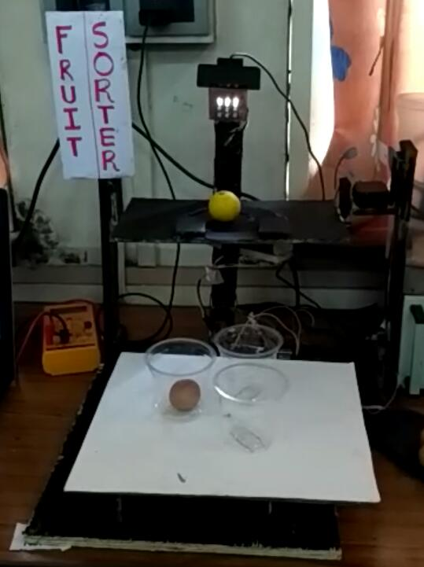

Figure 7.1 Hardware Setup

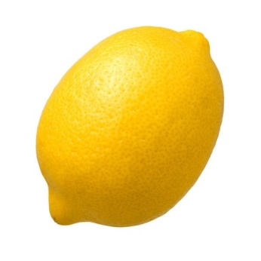 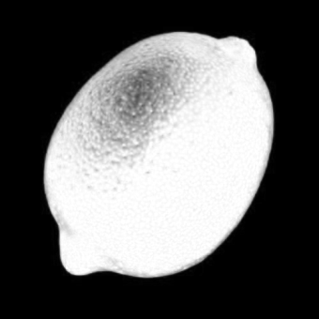 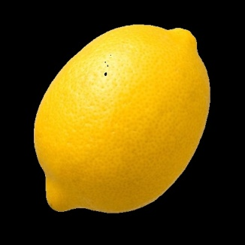

Figure 7.2 Lemon 1

25.7307 163.7867 115.0472 27.6119 88.7307 114.6948 33.02570177165052 93.33989395274669 102.92060518749392 31.900919710723073 81.84119731229498 103.3038878888883

[1.]

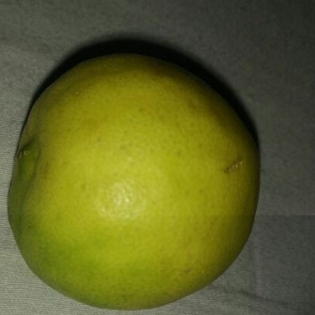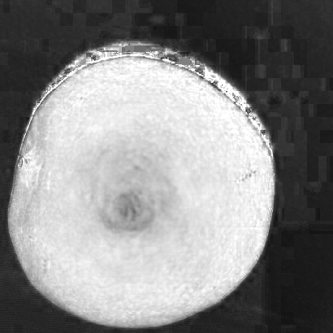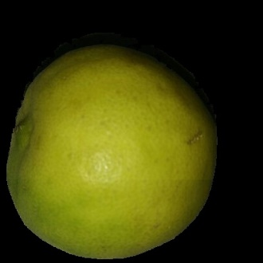

Figure 7.3 Lemon 2

24.0136449963477 152.02790357925494 80.2836523009496 12.735310445580716 79.40959094229365 78.1209495982469 19.29225964056716 101.80370358853024 67.27908790949206 15.854909328416735 67.08009886725065 66.00584991431643

[2.]

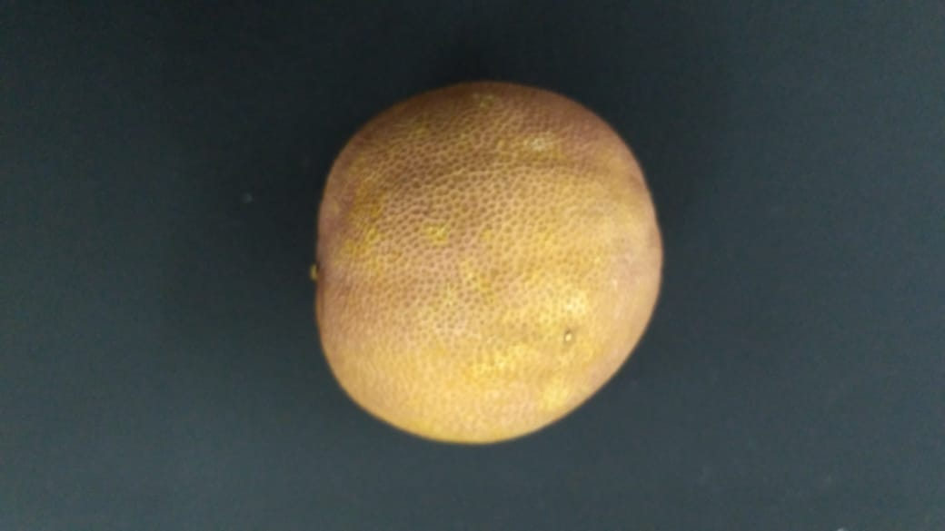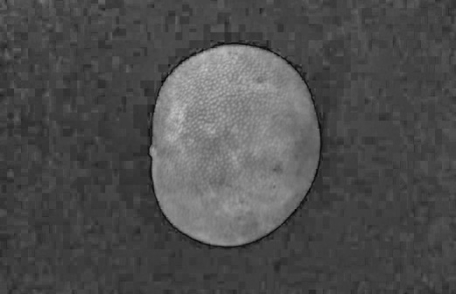 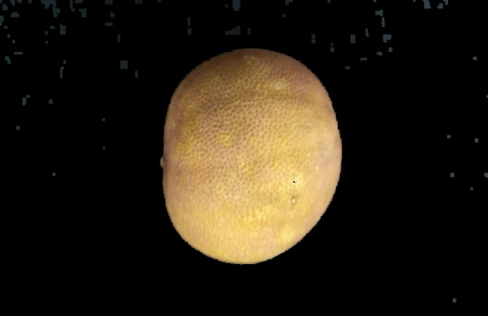

6.475956607495069 34.07709072978304 39.582177843524 19.840645956607496 31.90808842866535 39.38742932281394 17.853878573035086 64.23902276019665 80.01930835526771 40.52230766606706 65.39100993613866 80.03111046816124 6.475956607495069 34.07709072978304 39.582177843524 19.840645956607496 31.90808842866535 39.38742932281394 17.853878573035086 64.23902276019665 80.01930835526771 40.52230766606706 65.39100993613866 80.03111046816124

Table 7.4 Lemon 3

6.475956607495069 34.07709072978304 39.582177843524 19.840645956607496 31.90808842866535 39.38742932281394 17.853878573035086 64.23902276019665 80.01930835526771 40.52230766606706 65.39100993613866 80.03111046816124

[1.]

|  |  |  |
| --- | --- | --- |
| Type of lemon | Total | Correctly classified |
| Yellow (fresh) | 30 | 19 |
| Green (raw) | 15 | 9 |
| Brown (rotten) | 10 | 5 |

Table 7.1 Statistics

Figure 7.5 Result

**CHAPTER 8**

**CONCLUSIONS**

* We have successfully built a product which has a WebCamera on top of it to capture the images and a raspberry pi to process the image.
* We learnt the basics of OpenCV and Image Processing and implemented the detection of quality of fruit.
* We learnt the basics of Machine learning and learnt how to classify images using SVM.
* We have also learnt the Data training of objects, here watch to recognize the quality of lemon with an efficiency of 60-70 % efficiency.
* We learnt the Interfacing of Raspberry Pi with Webcam and Motors and Leds, and basics of python were one of the prerequisites of the project.

**CHAPTER 9**

**FUTURE SCOPE**

This project has a very wide range of applications and at the same time very vast scope. It can be used to implement the following modules:

Fruit Recognition

* Here we tried to implement the Fruit detection module of OpenCV which can be further expanded to Fruit Recognition Module, wherein our product will be able to recognize which fruit is there in the images. This will help the farmers to sort different types of fruits as well.

Machine Learning

* One of the major expansions is to implement different algorithms of Machine Learning on this module to train the device automatically and to get more efficient results.

Increasing the Data Set

* By increasing the data set for training of the machine we can increase the accuracy of the fruit detection, which is one of the major challenges in Image Processing.

Using Neural Networks

* Also by using Convolutional Neural Networks we can teach our machine to classify the fruits captured in the Image.

**CHAPTER 10**

**BILL OF MATERIALS**

**BILL OF MATERIALS**

|  |  |
| --- | --- |
| **COMPONENT** | **PRICE** |
| Raspberry pi | 2500 Rs |
| 16gb SD card | 550 Rs |
| Servo Motors | 1100*3=3300 |
| LEDs | 30 Rs |
| Jumpers and 0 PCB | 50Rs |
| Wood Pieces | 100 Rs |
| Webcam | 6500Rs |

Table 10.1 Bill of materials

Total cost of the project: 13030Rs

**CHAPTER 11**

**REFERENCES**

1. Chandra Sekhar Nandi, “Machine vision based automatic fruit grading system using fuzzy algorithm”, International Conference on Control, Instrumentation, Energy and Communication (CIEC) February 2014
2. MOTORS:- http://www.nex-robotics.com/products/legged-robotics/high-torque-rc-servo-motor-with-metal-gears.html.
3. Mostafa Khojastehnazhand, Mahmoud Omi “Development of a lemon sorting system based on color and size”, African Journal of Plant Science Vol. 4(4), pp. 122-127, April 2010
4. SVM:https://www.analyticsvidhya.com/blog/2017/09/understaing-support-vector-machine-example-code/
5. <https://www.coursera.org/learn/machine-learning>
6. . Ming Liang, Xiaolin Hu ,. Recurrent Convolutional Neural Network for Object Recognition, IEEE Conference on “Computer Vision and Pattern Recognition (CVPR)” Boston, pp. 3367-3375, 2015
7. Ajay Pal Singh Chauhan & Amar Partap Singh ,:- “Virtual Grader for Apple Quality Assessment using Fruit Size and Illumiation Features “,r Global Journal of Computer Science and Technology ( DGD ) Volume XIV Issue IV Version I 2014.
8. <https://en.wikipedia.org/wiki/Support_vector_machine>
9. <https://www.geeksforgeeks.org/learning-model-building-scikit-learn-python-machine-learning-library/>

**CHAPTER 12**

**DATASHEETS**

RASPBERRY PI 3 MODEL B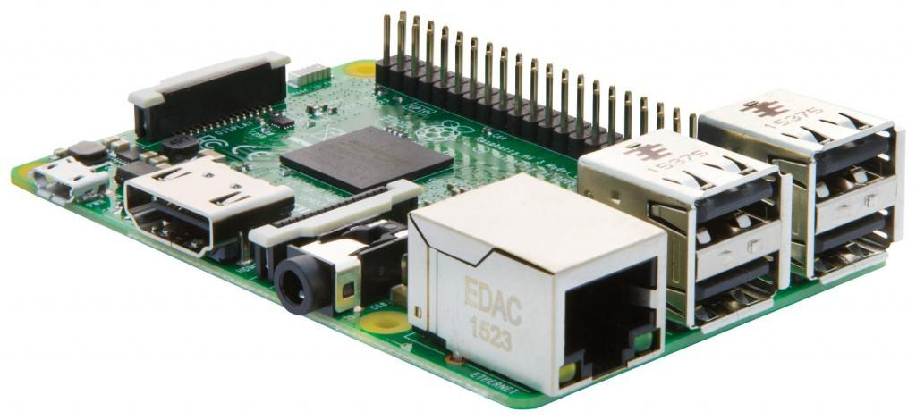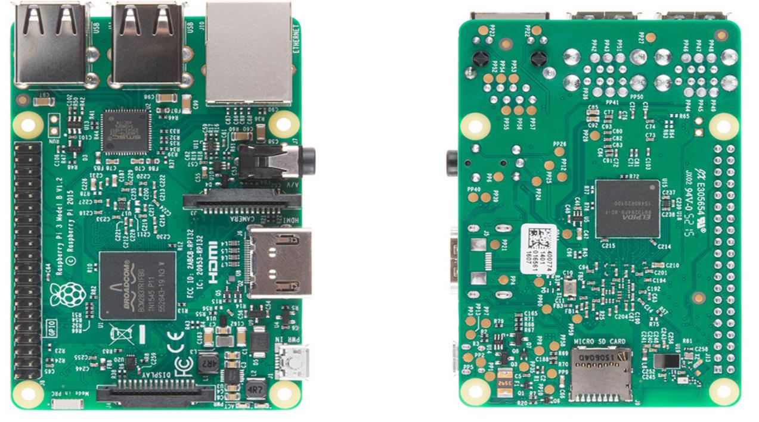

RASPBERRY PI 3 MODEL B

**Technical Specification:**

**Processor**

* Broadcom BCM2387 chipset.
* 1.2GHz Quad-Core ARM Cortex-A53 (64Bit)

**802.11 b/g/n Wireless LAN and Bluetooth 4.1 (Bluetooth Classic and LE)**

* IEEE 802.11 b / g / n Wi-Fi. Protocol: WEP, WPA WPA2, algorithms AES-CCMP (maximum key length of 256 bits), the maximum range of 100 meters.
* IEEE 802.15 Bluetooth, symmetric encryption algorithm Advanced Encryption Standard (AES) with 128-bit key, the maximum range of 50 meters.

**GPU**

* Dual Core Video Core IV® Multimedia Co-Processor. Provides Open GL ES 2.0, hardware-accelerated Open VG, and 1080p30 H.264 high-profile decode.
* Capable of 1Gpixel/s, 1.5Gtexel/s or 24GFLOPs with texture filtering and DMA infrastructure

**Memory**

* 1GB LPDDR2

**Operating System**

* Boots from Micro SD card, running a version of the Linux operating system or Windows 10 IoT

**Dimensions**

* 85 x 56 x 17mm

**Power**

* Micro USB socket 5V1, 2.5A

**Connectors:**

**Ethernet**

* 10/100 BaseT Ethernet socket

**Video Output**

* HDMI (rev 1.3 & 1.4)
* Composite RCA (PAL and NTSC)

**Audio Output**

* Audio Output 3.5mm jack
* HDMI
* USB 4 x USB 2.0 Connector

**GPIO Connector**

* 40-pin 2.54 mm (100 mil) expansion header: 2x20 strip
* Providing 27 GPIO pins as well as +3.3 V, +5 V and GND supply lines

**Camera Connector**

* 15-pin MIPI Camera Serial Interface (CSI-2)

**Display Connector**

* Display Serial Interface (DSI) 15 way flat flex cable connector with two data lanes and a clock lane

**Memory Card Slot**

* Push/pull Micro SDIO

The GPU provides Open GL ES 2.0, hardware-accelerated Open VG, and 1080p30 H.264 high-profile decode and is capable of 1Gpixel/s, 1.5Gtexel/s or 24 GFLOPs of general purpose compute. What’s that all mean? It means that if you plug the Raspberry Pi 3 into your HDTV, you could watch BluRay quality video, using H.264 at 40MBits/s

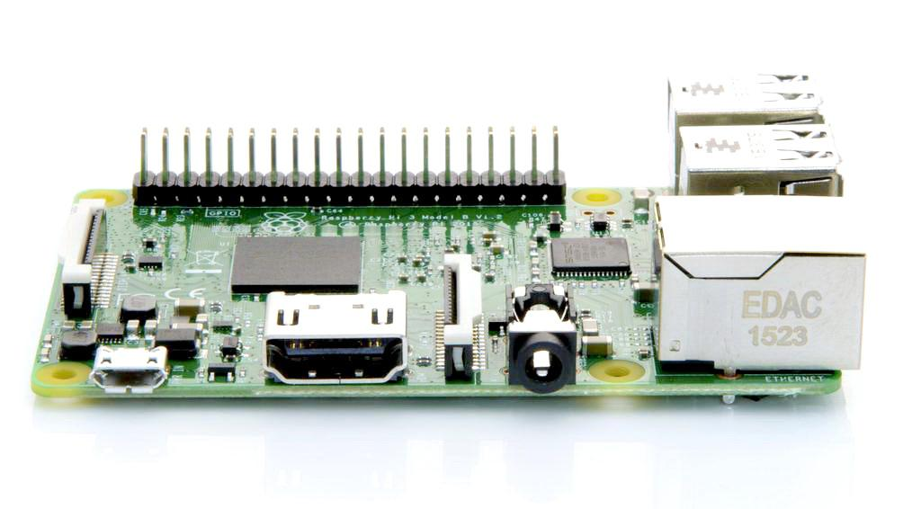

The biggest change that has been enacted with the Raspberry Pi 3 is an upgrade to a next generation main processor and improved connectivity with Bluetooth Low Energy (BLE) and BCM43143 Wi-Fi on board. Additionally, the Raspberry Pi 3 has improved power management, with an upgraded switched power source up to 2.5 Amps, to support more powerful external USB devices.

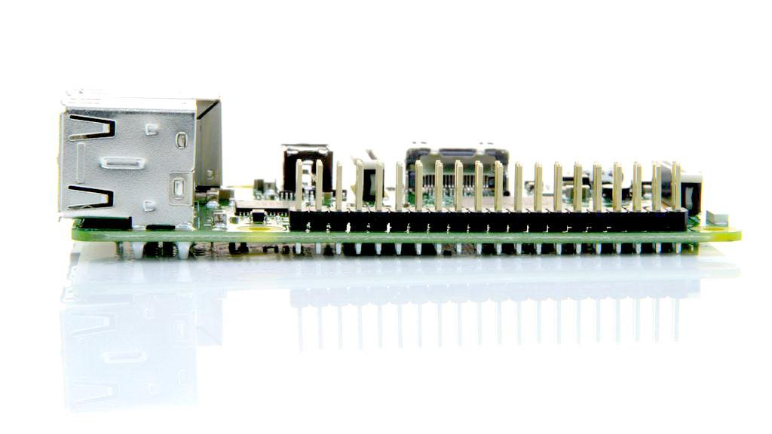

The Raspberry Pi 3’s four built-in USB ports provide enough connectivity for a mouse, keyboard, or anything else that you feel the RPi needs, but if you want to add even more you can still use a USB hub. Keep in mind, it is recommended that you use a powered hub so as not to overtax the on-board voltage regulator. Powering the Raspberry Pi 3 is easy, just plug any USB power supply into the micro-USB port. There’s no power button so the Pi will begin to boot as soon as power is applied, to turn it off simply remove power. The four built-in USB ports can even output up to 1.2A enabling you to connect more power hungry USB devices (This does require a 2Amp micro USB Power Supply)

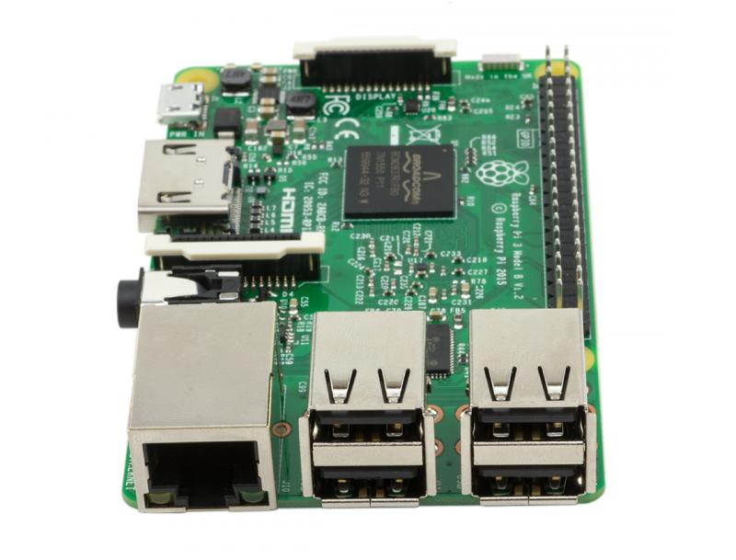

On top of all that, the low-level peripherals on the Pi make it great for hardware hacking. The 0.1" spaced 40-pin GPIO header on the Pi gives you access to 27 GPIO, UART, I2C, SPI as well as 3.3 and 5V sources. Each pin on the GPIO header is identical to its predecessor the Model B+.

**SoC**

Built specifically for the new Pi 3, the Broadcom BCM2837 system-on-chip (SoC) includes four high-performance ARM Cortex-A53 processing cores running at 1.2GHz with 32kB Level 1 and 512kB Level 2 cache memory, a VideoCore IV graphics processor, and is linked to a 1GB LPDDR2 memory module on the rear of the board.

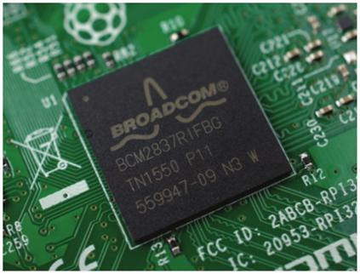

**GPIO**

The Raspberry Pi 3 features the same 40-pin general-purpose input-output (GPIO) header as all the Pis going back to the Model B+ and Model A+. Any existing GPIO hardware will work without modification; the only change is a switch to which UART is exposed on the GPIO’s pins, but that’s handled internally by the operating system.

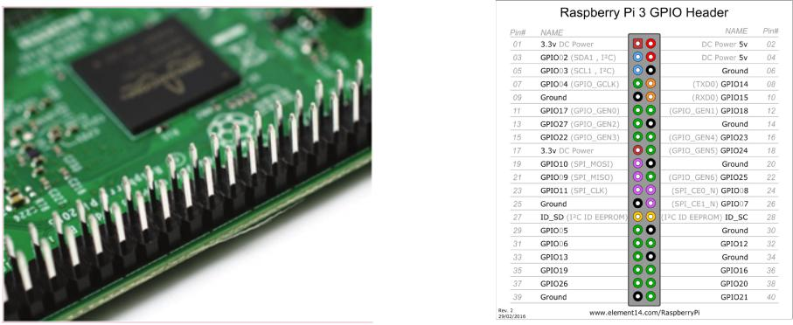

**USB chip**

The Raspberry Pi 3 shares the same SMSC LAN9514 chip as its predecessor, the Raspberry Pi 2, adding 10/100 Ethernet connectivity and four USB channels to the board. As before, the SMSC chip connects to the SoC via a single USB channel, acting as a USB-to-Ethernet adaptor and USB hub.

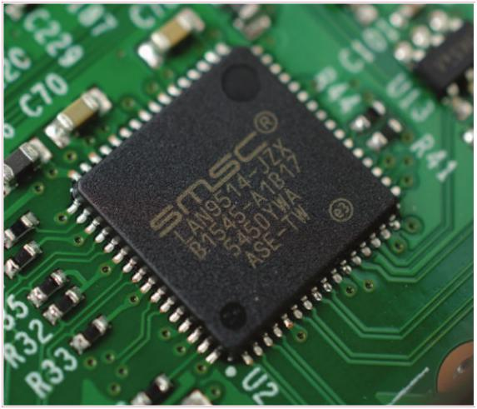

**Antenna**

There’s no need to connect an external antenna to the Raspberry Pi 3. Its radios are connected to this chip antenna soldered directly to the board, in order to keep the size of the device to a minimum. Despite its diminutive stature, this antenna should be more than capable of picking up wireless LAN and Bluetooth signals – even through walls.

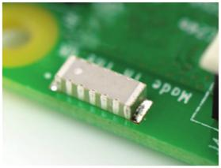

**Key Improvements from Pi 2 Model B to Pi 3 Model B:**

* Next Generation QUAD Core Broadcom BCM2837 64bit ARMv7 processor
* Processor speed has increased from 900MHz on Pi 2 to 1.25Ghz on the RPi 3 Model B
* BCM43143 Wi-Fi on board
* Bluetooth Low Energy (BLE) on board
* Upgraded switched power source up to 2.5 Amps (can now power even more powerful devices over USB ports)

The main differences are the quad core 64-bit CPU and on-board Wi-Fi and Bluetooth. The RAM remains 1GB and there is no change to the USB or Ethernet ports. However, the upgraded power management should mean the Pi 3 can make use of more power hungry USB devices

For Raspberry Pi 3, Broadcom have supported us with a new SoC, BCM2837. This retains the same basic architecture as its predecessors BCM2835 and BCM2836, so all those projects and tutorials which rely on the precise details of the Raspberry Pi hardware will continue to work. The 900MHz 32-bit quad-core ARM Cortex-A7 CPU complex has been replaced by a custom-hardened 1.2GHz 64-bit quad-core ARM Cortex-A53

In terms of size it is identical to the B+ and Pi 2. All the connectors and mounting holes are in the same place so all existing add-ons, HATs and cases should fit just fine although the power and activity LEDs have moved to make room for the WiFi antenna.

The performance of the Pi 3 is roughly 50-60% faster than the Pi 2 which means it is ten times faster than the original Pi.

All of the connectors are in the same place and have the same functionality, and the board can still be run from a 5V micro-USB power adapter. This time round, we’re recommending a 2.5A adapter if you want to connect power-hungry USB devices to the Raspberry Pi.

Raspberry Pi 3 Model B Raspberry Pi 2



              
              
              

